# Table of contents

Table of Contents

Table of Contents 2

Table of Figures 2

Table of Tables 2

Abstract 2

Chapter 1: Introduction 2

Chapter 2: Research Design 2

Primary Data 2

Problem Identification and Clarification 2

Research Objectives 3

Chess Engines and the Horizon Effect 3

Player Rating and Opening Move Distributions 3

Chess Engine Evaluation and Real-World Outcomes 4

Recommendation system 4

Validity Type 4

Ethical Considerations 4

Chapter 3: Literature Review 5

Chapter 4: Methodology 6

4.1 Data Collection and Pre-Processing 6

4.2 Puzzle Analysis 6

4.3 Player Opening Distribution Analysis 8

4.4 Opening Analysis 9

4.5 Recommendation System 10

Chapter 6: Results 12

6.1 Puzzle Analysis 12

6.2 Player Opening Distribution Analysis 13

Chapter 7: Discussion 13

Chapter 8: Conclusion 14

Appendix A: Workflow 14

Appendix C: Data Permissions 14

Reference List 14

# Table of Figures

# Table of Tables

# Abstract

Here I will outline the actions performed in this thesis along with a brief description of the topic and results.

# Chapter 1: Introduction

This section will define the problem, the background behind it, and the expected outcome as a result of the analytics performed

# Chapter 2: Research Design

The following section will detail the process of identifying a subject of research in this report and detail the specific objectives that were derived to address the research problem. The research objectives are broken down by the tasks required to address the problem and the gain that they will provide with respect to the research. Alongside this, the identification of a source of primary data is detailed which describes both the method of sourcing through experimentation and the specific use case for the data once established.

## 2.1 Primary Data

Primary data for the problem set identified in this research will be established through an experimental process of the application of two of the top chess engines Stockfish and Leela Chess Zero to a collection of defined solution *Mate in X* puzzles. By running the engines on these puzzles, parameters for time of search and depth of search will be collected and statistically compared to evaluate any possible power gain in the selection of one engine over another. Furthermore, the engine with higher established capabilities will be incorporated into the development of a recommendation system in the form of developing a new metric for ranking openings by value gain rather than win rate. With this new metric established a comparative analysis will determine the feasibility of using engine-derived information for practical use outside of a game specific analysis scenario.

## 2.2 Problem Identification and Clarification

Chess, a game that requires players to employ both their knowledge of tactics and to derive their assessment of positions, requires the implementation of the analysis of data throughout every game. Originally, chess games like many problem sets, required a thought-driven analysis on a human level. But chess analytics and many other fields have changed significantly with the implementation of machine learning with the development of chess engines.

Since the inception of chess algorithms in the 1940s by Claude E. Shannon (Shannon, 1950) and Alan Turing (Turing, 1953), they have changed the approach to the game with interest from both players and mathematicians. Algorithms devised for chess engines come in many formats, such as human-designed, Alpha-Beta-Pruning based engines like Stockfish (Stockfish, n.d.) and Neural Netowrk designed, Monte-Carlo Tree search engines like Leela Chess Zero (LeelaChessZero, 2023). This diversity in engine design offers different approaches to the assessment of a chess position. It creates natural competition to find the most potent position evaluation methodologies, which can be seen in the Top Chess Engine Championship, with both Stockfish and Leela Chess Zero having won the title of champion within the last decade (Wiki, 2023).

With chess engines being available to players for post-game and specific position analysis, the goal of this project is to expand the use-case of the data analytics tools known as chess engines to provide players with recommendations of openings to aid in the expansion of their repertoire. By using a chess engine to study openings and the progression of games played with those openings, an alternative evaluation metric could provide a better ranking basis for openings when compared to the overall player success rate.

The process of determining the feasibility of this must consider the following objectives: determining the engine which is most capable of assessing a position given limited computational ability; understanding the potential difference in the analysis of openings when compared to real-world outcomes; the uncovering of potential opening selection dynamics based on the scaled rating of players within chess datasets; and the evaluation and justification of recommendation differences identified by establishing alternative valuation metrics.

## 2.3 Research Objectives

### 2.3.1 Chess Engines and the Horizon Effect

Chess engines incorporate different algorithms for the determination of the optimal line of play in a given position. Stockfish incorporates an Alpha-Beta Pruning search algorithm that uses human-trained heuristics and weightings to determine the value of search paths and the cutoff points for the pruning of its search nodes. Leela Chess Zero uses an alternative search method known as the Monte-Carlo Tree search, which randomly iterates through more linear search nodes to reach an optimal solution. Unlike Stockfish, Leela Chess Zero is trained through a neural network, which through a series of games played against itself, developed its heuristics and weights to evaluate each search node.

The horizon effect is an obstacle for search algorithms where a solution to a problem lies beyond the depth restriction of a search algorithm, such as the depth limit option in Universal Chess Interface compatible engines like Stockfish and Leela Chess Zero.

The objective here is to evaluate and justify any measurable difference in the parameters required by engines with different problem-solving approaches in finding the pre-determined solution based on end-game puzzles.

### 2.3.2 Player Rating and Opening Move Distributions

With a large variety of standardised chess openings available to everyone who plays a game of chess, players can be as selective as they wish regarding how they approach the initial stage of a game. Considering behaviours expected at different skill levels, a reasonable assumption would be that highly skilled players would be somewhat selective of their openings and maintain a lower diversity in their selection. Using ecological diversity metrics, statistical methods, and machine learning applied to real-world data, this section aims to establish the possible rating divisions within the chess player population at which selection approaches of openings differ.

Furthermore, this exploration will aim to provide insight into the pool of openings selected by players. By establishing a possible pattern between a player at a particular skill level and the openings they choose from, information may be further incorporated into new areas of research, such as the development of a recommendation system to help inform players of openings that would be suitable for their play style or historical use.

### 2.3.3 Chess Engine Evaluation and Real-World Outcomes

Chess Openings are defined by a classification based on codes from the Encyclopaedia of Chess Openings (ECO), (Matanovic, 1978), which can be further subdivided into sections: Opening, Line, and Variation. The Opening is the initial moves played, the Line is the approach taken after these moves, and the Variation is a slight difference to change the overall tactical approach of the opening.

A famous example is the “Queen’s Gambit”, and its lines and variations are classified under the umbrella of code D06 and its variations under codes D07-D69. Each opening has a use case depending on the player's desired approach to the game concerning time control and even knowledge of the opponent and their repertoire, but this is more so the case in classical over-the-board games.

Each opening has various success rates with different players. This is due to the opponent being able to vary the game significantly with every possible move after an opening is played hugely increasing the number of permutations a board can take. Given a chess engine’s ability to search both wider and deeper than a human, the purpose of this analysis is to derive insight into the possible benefits of a chess engine analysis can be considered concerning the real-world outcome of chess games.

### 2.3.4 Recommendation system

The final objective of this research project will leverage the insights gained in the previous objectives by introducing a recommendation system as a real-world application of analytics that can be derived from historical chess data and chess engines. Combining the analysis gained from the exploration of chess engines and their evaluation of games based on their opening with the understanding of player-opening relationships, the impact of metrics and groupings on a recommendation system can be derived and interpreted.

This integrated objective will serve as a demonstration of the synergistic nature of the objectives in this project and as a suitable application of the primary data obtained in the evaluation of chess engines.

## Validity Type

## 2.4 Ethical Considerations

Due to the nature of this project relying on open-sourced and free-to-use chess engines in combination with open-licensed data, there are no ethical considerations concerning fair usage. Both Stockfish and Leela use a GPLv3 license, meaning general use is under no restrictions and that any adjustments to source code must be documented, and the original source must be packaged with the adjusted program; attribution is also necessary. Data from Lichess's database is under Creative Commons 0 (CC0), which allows for complete access and usage without any attribution, but their website notes that it is appreciated. The use of data from Lichess is also supported and encouraged by the company.

Ethics regarding personal data are not of concern due to no personal identifying data collected in the PGN format from chess games except for usernames which belong to Lichess, which they are free to distribute.

Results from this project are obtained from using open-sourced engines on free access data. From this, all results will not be restricted and will have no ethical concerns regarding publishing.

Consideration must be given to establishing power gain from a chess engine given a specific subset of puzzles for testing. It is to be understood that this report does not imply an objective superiority of one engine over another for all uses. Readers can evaluate engines based on results from chess engine-specific comparative sources such as Top Chess Engine Champion (Wiki, 2023), which hosts competitions for engine developers to submit their engines for tournament and league head-to-head comparisons.

# Chapter 3: Literature Review

# Chapter 4: Methodology

## 4.1 Data Collection and Pre-Processing

All data for this project was sourced from Lichess.org. Lichess provides a database of all games played on the website every month and makes them available for use under the Creative Commons 0 License. Along with this they also publish all their puzzles along with games played.

The games are available as Portable Game Notations (PGN) files. These can be read as text documents and contain essential information about games, such as player names, their ratings, the result, time control, and the moves played in the game.

PGN as a database format is standardised for Universal Chess Interface (UCI) software but does not allow for easy importation into analytics tools such as Excel or Python, specifically Pandas. To account for this, a program with a specific function was developed to process a PGN format database of 200 plus Gigabytes of data into a usable CSV format.

The key problem to solve with this was handling the massive amounts of data due to be processed. To circumvent this issue, the text file was read in line by line, where the indicator of information piece for each game would allow it to be assigned a position in a dictionary. This dictionary was then continually appended to itself for every new game. Once enough games had been processed, was converted to a format that could be deposited in a Comma Separated Values (CSV) file at regular intervals to avoid the over usage of temporary memory and to allow for a continuation given a spontaneous failure as the process had to run for several days.

Once a sufficient number of games had been reached, in this case 10 million the function was interrupted, and the data was available for use. The number of games was determined by a combination of processing power, temporary memory available for importing of data, and in particular time limitations. Due to the nature of processing a large text file and being unable to import into temporary memory because of storage limits, the line-by-line approach allowed for consistent processing at a regular pace reducing the strain of processing power and memory availability.

Although there were tools available for public use on GitHub that could allow for imports into memory for processing, their splits were based on memory size rather than by games which may have split games in two resulting in their data being unavailable for processing. As this selective exclusion of games may have resulted in bias within the aims of this research, this method was determined to be less desirable to the text file processing method.

## 4.2 Puzzle Analysis

A database of puzzles was obtained from Lichess Puzzle Database (Lichess, 2023). This is an open database published by Lichess to provide its users with access to all the puzzles they use on their site. It also includes summary statistics for the puzzles.

The Comma Separated Values file provided by Lichess.org was imported into a Python environment using Pandas where it was filtered to extract all the puzzles fitting a ‘Mate in X’ description. This provided a variety of different puzzles on which an analysis could be performed to establish the difference between engine horizon problem-solving capabilities.

To provide sufficient testing for the engines, a range of mate lengths was chosen from the longest available. The database consisted of a range of ‘Mate in X’ problems ranging from 1 move to 10 moves. Five was chosen as the lowest value to provide a depth where the engines would need to execute a minimal search and 8 was chosen as the upper limit to allow for enough comparison in distribution for the selected engine parameters. Both populations for ‘Mate in 9’ and ‘Mate in 10’ puzzles would not have provided a large enough sample to compare distributions, both having 9 and 2 puzzles respectively, whereas puzzles with 5, 6, 7, and 8 moves have 3058, 2320, 503, and 183 puzzles in their samples.

A Python program using the Python-Chess library (Python-Chess, 2023) was developed to implement an experimental procedure to test both Stockfish and Leela Chess Zero, two of the top open-source engines. In this program, a custom function was developed to utilise the python-chess Universal Chess Interface (UCI) *analyse* function in an open-ended analysis of each puzzle. This analysis allowed the engines to access the puzzle and perform their search until a mate with the expected X value was found. Once found the function would cease its execution and return the parameters the engine had used to find its solution to the ‘Mate in X’ puzzle.

This approach was found to have more granularity for analytics as opposed to the Python-Chess engine limit protocol. By providing defined limits for depth of search and time searching, the engine would be tested multiple times to see at which combination of parameters it could determine a solution. The results of this process showed multiple combinations of depth and time that provided solutions for each problem but did not allow the engine to approach the problem in its base state. The change to an indefinite analysis pending a solution allowed each tested engine to approach the puzzle and return an exact combination without intervention by the tester.

The results from each search by the engine were returned as an information dictionary as dictated by each of their UCI protocols. Although these Python dictionaries had different formatting, they both contained the parameters of interest for this experiment: *time*, *seldepth*, and *nodes*. The *time* is defined as the time until a solution was reached, *seldepth* is defined as the depth at which the accepted solution was selected, and *nodes* are the number of branches searched by an engine in its approach to finding a solution.

Once all the above parameters were extracted from the engines during the analysis process, each distribution was compared to its corresponding parameters for each categorical ‘Mate in X’ group to provide a one-to-one experiment.

All statistical tests performed were tested with an alpha = 0.05. This is an established value proposed by Fisher as a means to suggest a cutoff point where confidence could be attributed to a result (Fisher, 1954). This value is used conventionally in many types of research and is generally considered that 95% is an acceptable confidence level (Thiese & Ronna, 2016).

As distributions were being compared, the correct statistical tests had to be selected to ensure an accurate comparison of data was being performed. The choice of test was primarily driven by whether the data was likely to conform to a normal distribution or not, which required its own statistical test. The Shapiro-Wilk test was used to assess whether the Null Hypothesis that each of the distributions for the individual variables split by category was normally distributed. As both *seldepth* and *nodes* are discrete values, non-parametric tests would be the choice for them.

The Shapiro-Wilk test tests for normality in distributions by comparing the assumption that the distribution would adhere to a normal curve and generating a test statistic based on the deviation from normality (SHAPIRO & WILK, 1965). The hypothesis for the test in this case was for *time* distributions being normal given a P-value of 0.05. All results for this test showed that the distributions were not normally distributed meaning the comparative tests would need to be non-parametric.

The Mann-Whitney U test is a non-parametric comparative test that is considered as powerful as the parametric t-test (MacFarland & Yates, 2016) which is one of the most common tests used in research journals (Yim, et al., 2010). Due to its usefulness as a comparative test, it was implemented into this analysis to compare equivalent engine parameters between engines within their respective ‘Mate in X’ categories.

The results of the Mann-Whitney U test were checked to determine whether the distributions were similar, and boxplots were used to plot the display the parameter values for visual comparison of quartiles and median values. The values for *seldepth* were plotted with a normal range y-axis of values and the *time* and *nodes* parameters were plotted using a Log range y-axis to allow the data to be read with granularity with the skewed nature of the values.

## 4.3 Player Opening Distribution Analysis

This objective aimed to investigate and determine the relationship between players, their ratings, their diversity in the selection of openings, and the pools of openings they may be more inclined to select from. Given the sample of 10 million games obtained from Lichess, a pre-processing procedure was required to refine the sample of games into a dataset that is appropriate for the investigations outlined for this section. The particular filters chosen to refine the dataset were based on the topic of appropriate openings, frequency of opening use by players, and volume of games played by players in order for there to be sufficient data to base estimations on.

Appropriate openings were chosen by the complexity required to analyse the collection of openings. Using the naming convention of Opening, Line, and Variations for differentiating openings, there were 3,398 distinct openings. With the Variation inclusive openings being used to a lesser degree by the entire population and being highly dependent on the response by black, they were excluded to reduce granularity within the dataset and provide a more focussed analysis resulting in 1,478. Black openings, when considered were dependent on the initial moves played by white. As this would have required a sub-analysis that generalised this objective to a degree that would require a much lengthier and more complex research procedure, they were excluded to allow this research to focus on openings that could be chosen rather than required by a player, resulting in 423 openings remaining.

The refinement of openings used was then further applied by the assessment of the minimum volume of occurrence for an appropriate analysis. Given that sampling at 10% of the total population would be required for the engine analysis of games within this research project, only openings played one hundred times or more would be assessed. This had the positive effect of reducing the input of infrequently played games into the clustering methods that were employed later.

The third filter applied was for openings that were not used by ten or more unique players would not be considered. This requirement was established by testing the diversity metrics within the data. When openings were played by less than ten players, it resulted in many fixed values of the diversity metrics, which skewed early attempts at clustering.

The final filter for the dataset of games was based on the volume and diversity of games played by users. To consider player diversity similarly to the opening diversity, a minimum limit of having played 10 games within the first 10 million 10+ minute games played in June 2023 on Lichess was required to avoid the diversity index spikes. Additionally, to ensure association suitability, players had to have used two or more openings. Without this requirement, the clustering efforts would have been skewed by players that only ever stuck to one opening, which was consistently 0 for these players who were out of scope for the primary research objective.

With the population of games being finalised based on the filters for both openings and players, analyses were performed to determine both the diversity in opening choice by players based on rating and to determine the points at which players chose from different pools of openings within the entire available population.

#### 4.3.1 Opening Diversity

The approach in this section was to use a combination of diversity metrics based on providing sufficient information to allow for a balanced approach. The particular non-parametric diversity measures chosen for this objective's assessment were the Gini Impurity Index and Shannon Diversity Index. A research paper in XYZ determined these indexes to be suitable in providing measurements in different ways that account for variety in occurrence and balance in occurrence respectively (Stirling, 2007).

With both of these calculated for each player and their use of each opening within the dataset, the data was brought forward for machine learning analysis. The K-Means Clustering method provides a suitable algorithm for the assessment of these items due to its properties of simplicity in implementation and scalability with large data (Ning & Liu, 2022) which is a concern given the population of unique players being 110,662.

By combining player rating, Gini diversity and Shannon diversity indexes as input into the clustering model, a process of determining optimal clusters was performed by assessing multiple cluster values denoted as K. K being the input integer value, in this case of a range of 1-10, was tested as the cluster value and assessed using a combination of the “Elbow Method” and the “Silhouette Method”. The “Elbow Method” is one of the oldest approaches for determining K within K-Means clustering but has the disadvantage of being a subjective measure by the user (Shi, et al., 2021). To counter this, the secondary measure of the “Silhouette Method was incorporated as it has the advantage of being non-resource intensive and having simple evaluation metrics (Dudek, 2020).

#### 4.3.2 Player Opening Selection

After assessing the results of this clustering procedure, a contingency table was used to investigate further the differences between different rating groups and their selection of openings. Using a simple binning procedure to determine three even splits as a form of testing, a chi-squared test for a contingency table on the bins crossed with all opening use showed statistical significance in the difference between rating groups and their opening use. This implied that there was rationale for the clustering analysis of opening use and player rating.

In order to cluster on the categorical opening variable, the dataset was transformed into *Count Encoded* format data*. Count Encoding* is a method similar to one-hot encoding that retains information about the volume of occurrences within the dataset. With this transformed dataset, the data could be fed into a clustering method as previously performed in the diversity analysis section of this method. The value of K was interpreted based on the combined output of the *Elbow Method* and the *Silhouette Method,* and distinct clusters were obtained from the final implementation of the clustering algorithm.

## 4.4 Opening Analysis

The objective of analysing openings using chess engines was driven by the computational advantage of the depth of search in comparison to a typical human assessment of a chess position. By taking the engine evaluation of the starting point of an opening and comparing it at regular intervals in multiple games, the general trend of game results can be measured. The advantage to be determined by this possible approach is the negation of critical blunders or time control having a detrimental effect on the outcome of a game.

The first consideration for this procedural analysis of games was the engine to be used. After the puzzle analysis, it was found that Stockfish was the optimal engine for a combination of time required, depth of search possible, depth of search required to find optimal pathways, and nodes search through its algorithms.

The output-filtered game dataset from the player opening distribution analysis was used as the key dataset for understanding games. It contained the population of games and players that are for consideration for further analysis of a recommendation system. Containing 2,777,554 games, any meaningful analysis from an engine would take months given a fair evaluation time of 1 second or more. Early tests showed selected search depths of analysis between 9 and 12 when time was limited to 0.01 seconds in order to analyse more games. This resulted in standard deviations that negated any value from the mean engine parameters collected, with games of the same position also having different evaluations.

To counter this computational limit, a stratified sample of 1% of the dataset resulting in 27,776 games was implemented, stratifying on the openings used and a win/not-win variable to ensure proportions of success were considered within the sample analysis. This sampling allowed a scaled up increased time analysis which resulted in higher search depth, allowing for a more even assessment of the positions. Another key restriction implemented was the restriction of access to a hash table. Stockfish, once opened, can hold onto previous analyses, and use these as information on whether a position is strong or not. In order to allow for a fair assessment of every position independently, the hash table was cleared between each game processed by the engine.

Once the engine limit for time was established, a program set up to continually analyse for multiple days had to be established. To avoid loss in case of sudden hardware or software failure, the program was designed to process the dataset in chunks and iteratively write the results to a CSV file. By performing the analysis with this method, computational resources were freed to help counter possibilities of temporary memory shortage and allow the engine run smoothly.

Post completion of the engine analysis, the data was transformed such that each opening contained mean and median evaluation metrics, in this case centipawn value, the depth of search at which the evaluation was selected, and the nodes required in the search.

To determine the relationships between the win/loss ratio of openings and the positional evaluations from chess engines, the Pearson correlation values were used to create a heatmap to each of the metrics and their correlation. Along with this, a linear regression analysis was used to show the trend relationship between the median evaluation for all the games in each opening and the win/loss ratio. This analysis was used to set expectations with regards to the difference in recommendations from the different metrics, with high correlation and trend indicating a possibility for recommendations to have high similarity.

## 4.5 Recommendation System

With the previous objectives complete, the integration of the results and insights gained could be utilised in the development of a recommendation system with the aim of understanding the impact of design and evaluation metrics within the real-world application of data analytics.

By combining the data obtained in the other objectives, a reference dataset was curated to provide a basis of aggregation data based on players and player-opening combinations. This reference dataset contained all games that had been processed and extracted from the Portable Game Notation file, which provided a basis for establishing behavioural metrics for each game a player participated in as white. Once the opening moves had been played, the next 20 moves played by the white player were collected and processed to determine the count of the following metrics:

|  |  |
| --- | --- |
| **Metric** | **Explanation** |
| Pawn Moves | Any move with the action of moving a pawn from its square. |
| Centre Pawn Moves | Moves of a pawn in the *d* and *e* files to control the centre of the board. |
| Flank Pawn Moves | Moves of a pawn in the aand h files to control the edge of the board. |
| Non-Pawn Piece Moves | Any move with the action of moving a Knight, Bishop, Rook, Queen, or King |
| Developing Play Minor Piece Moves | Any move involving a minor piece not on the player’s backrank |
| Retreating Play Minor Piece Moves | Moves of a minor piece back to the player’s backrank |
| Centre Minor Piece Moves | Moves of minor pieces into the centre files of the board |
| All Minor Moves | Moves of any minor pieces |
| Developing Play Queen Moves | Moves of the queen to any squares except for the player’s backrank |
| Retreating Play Queen Moves | Moves of the queen to the player’s backrank |
| King Moves | Moves of the king in the player’s backrank |
| King Push | Moves of the king outside of the player’s backrank |
| Castles | A defensive manoeuvre of moving a previously unmoved King two squares right or left while moving the Rook adjacent to the King in the opposite direction. |
| Checks | The act of directly attacking the opponent’s King using any piece. |
| Captures | Taking an opponent’s piece using any piece. |

With these metrics calculated, the process of determining the correct method of providing a collaborative filter-based recommender system was to be decided upon. With behavioural features available, it was technically possible to estimate user success on openings based on their features using regression. An assessment of this method using multiple regressors from Scikit-Learn was performed and, as laid out in TABLE XYZ in APPENDIX ABC, showed little promise due to their generally low r2 values.

The second method to consider for both behavioural recommendation and player win probability recommendation was matrix factorisation cosine-similarity-based collaborative filtering. This method is widely used in industry with much success in accuracy (Wang, 2018), but it has the downside of difficulty in scalability. This was seen here, with a player population of 110,662; a cosine-similarity matrix for behavioural metrics required 70.6 Gigabytes of memory to produce, or 27.1 Gigabytes required when using a sparse matrix. As this level of computing hardware was not an option during this project, an alternative method was assessed.

The final method assessed was the Nearest Neighbours algorithm, similar to the KNN clustering algorithm seen earlier in this methodology. This method used in collaborative filters and in collaborative filtering comparison studies has been shown to consistently perform among the top contenders along with other traditional methods like matrix factorisation (Anelli, et al., 2022).

The aggregated datasets at both a player level for behavioural recommendation and a player-opening level for player-opening success ratio recommendations were transformed as appropriate and fed into a function that returned a Pandas DataFrame of opening recommendations for each player.

This function took the interaction matrices of the inputs for each recommendation type and created a sparse matrix to free up memory resources when performing the Nearest Neighbour recommendation. A loop within the function iterated over each player and found the most similar players based on either the behavioural information of the players or the players that were most successful with the openings the iterated player was using at the time. Once an inputted *N* openings had been collected from the most similar players, they were ranked by either the overall opening win/loss ratio, the evaluation at the end of the opening sequence, or the evaluation ten half-moves after the opening sequence. The *N* openings collected for this assessment and comparison of recommendation metrics was ten.

This procedure was then also performed on the clusters established in the player-opening distribution section of this report. These clusters identified players that selected their opening moves from different pools of openings. To find an impactful application of the cluster determination, a comparison of these recommendations to the non-clustered recommendations provided a point of reference to understand the effect of pre-grouping for the recommendation system.

Once a list of recommendations had been produced for each player based on each metric and for the grouped populations, two metrics were used to determine the similarity between these lists. Jaccard similarity finds the ratio of intersections of lists to the union of a list. It provides a key numerical value to understand the overlap between lists. It is a comparison method that is known for use with recommendation systems as an index for the formulation of drawbacks of a recommender system (Bag, et al., 2019). To add another dimension of comparison, sequence similarity was incorporated, which is often used in the field of molecular biology. It’s use case here is similar in that it can determine relationships between unannotated sequences (Anon., 2019), which for this research objective is lists of recommendations. The combination of Jaccard and Sequence similarity provides a numerical indicator of both item similarity along with order similarity.

# Chapter 6: Results

## 6.1 Puzzle Analysis

Table 1 - Result of Engines Solving Mate in X Problems

|  |  |  |
| --- | --- | --- |
| **Mate Puzzle Solved?** | **Stockfish** | **Leela Chess Zero** |
| Yes | 3046 | 3023 |
| No | 1 | 24 |

Here Stockfish shows an indication that it has a better overall ability to overcome search horizons more effectively by solving all but one of the Mate in X puzzles provided to it. Leela Chess Zero also performed well given the task, solving all but 0.8% of the puzzles, with one of the unsolved being the same as the one Stockfish did not manage to solve.

Table 2 - Result of Shapiro-Wilk test for Stockfish and Leela Chess Zero Evaluation *time*

|  |  |  |
| --- | --- | --- |
| **Mate in X** | **Stockfish (Statistic, P-Value)** | **Leela Chess Zero**  **(Statistic, P-Value)** |
| 5 | (0.06541, <0.001) | (0.24242, <0.001) |
| 6 | (0.13197, <0.001) | (0.28906, <0.001) |
| 7 | (0.37938, <0.001) | (0.35686, <0.001) |
| 8 | (0.59305, <0.001) | (0.40843, <0.001) |

Table 3 - Result of Whitney-Mann U test for Parameter Comparison

|  |  |  |  |
| --- | --- | --- | --- |
| **Mate in X** | **Time**  **Stockfish < Leela Chess Zero (Statistic, P-Value)** | **Seldepth**  **Stockfish < Leela Chess Zero**  **(Statistic, P-Value)** | **Nodes**  **Stockfish > Leela Chess Zero**  **(Statistic, P-Value)** |
| 5 | (171289, <0.001) | (1714897, <0.001) | (4305251, <0.001) |
| 6 | (19794.5, <0.001) | (89463.5, <0.001) | (195024.5, <0.001) |
| 7 | (7321, <0.001) | (12230.5, <0.001) | (27207.5, <0.001) |
| 8 | (299, <0.001) | (490, 0.002) | (1135, <0.001) |

The Shapiro-Wilk test uses the Null Hypothesis that a distribution follows a normal distribution. The results of the Shapiro-Wilk test displayed in Table 1 for Stockfish parameter normality shows a consistent result of P-value < 0.05 wherein the Null Hypothesis can be rejected such that the data is considered non-normal. Non-normal distributions are seen in Table 2, where a P-value < 0.05 indicates the distribution of *time* values obtained from the engine analysis by Leela Chess Zero can be compared with Stockfish *time* values using a non-parametric test.

With the results seen in Table 2 indicating non-normal distribution of values, the Mann-Whitney U test was used. The results can be seen in Table 3 where a collection of test statistics and P-values are displayed for each engine parameter collected between the two chess engines for each of the categorical ‘Mate in X’ values. In these results Stockfish outperforms Leela Chess Zero in terms of a reduction lower time needed to solve, a lower overall depth of search required to come to a ‘Mate’ conclusions and a higher volume of nodes searched within the time of analysis. The *time* and *seldepth* are indicative of higher performance with respect to search horizon problems, whereas the *nodes* difference is expected given the different search structure of Alpha-Beta Pruning algorithms versus Monte-Carlo Tree Searches.

The combination of a both higher solve rate and more efficient search parameters indicates that Stockfish has an overall better performance with respect to the Horizon Effect, making it the choice engine for this project in analysing openings and their effect on a chess game.

The results of the statistical tests are confirmed with a visual analysis of the results for the *Mate in X* analysis. These boxplots show overall lower median values for *time* and *seldepth* while also displaying the *nodes* used by each engine, with Stockfish taking the lead against Leela Chess Zero.

Figure - Time Comparison of Stockfish and Leela Chess Zero

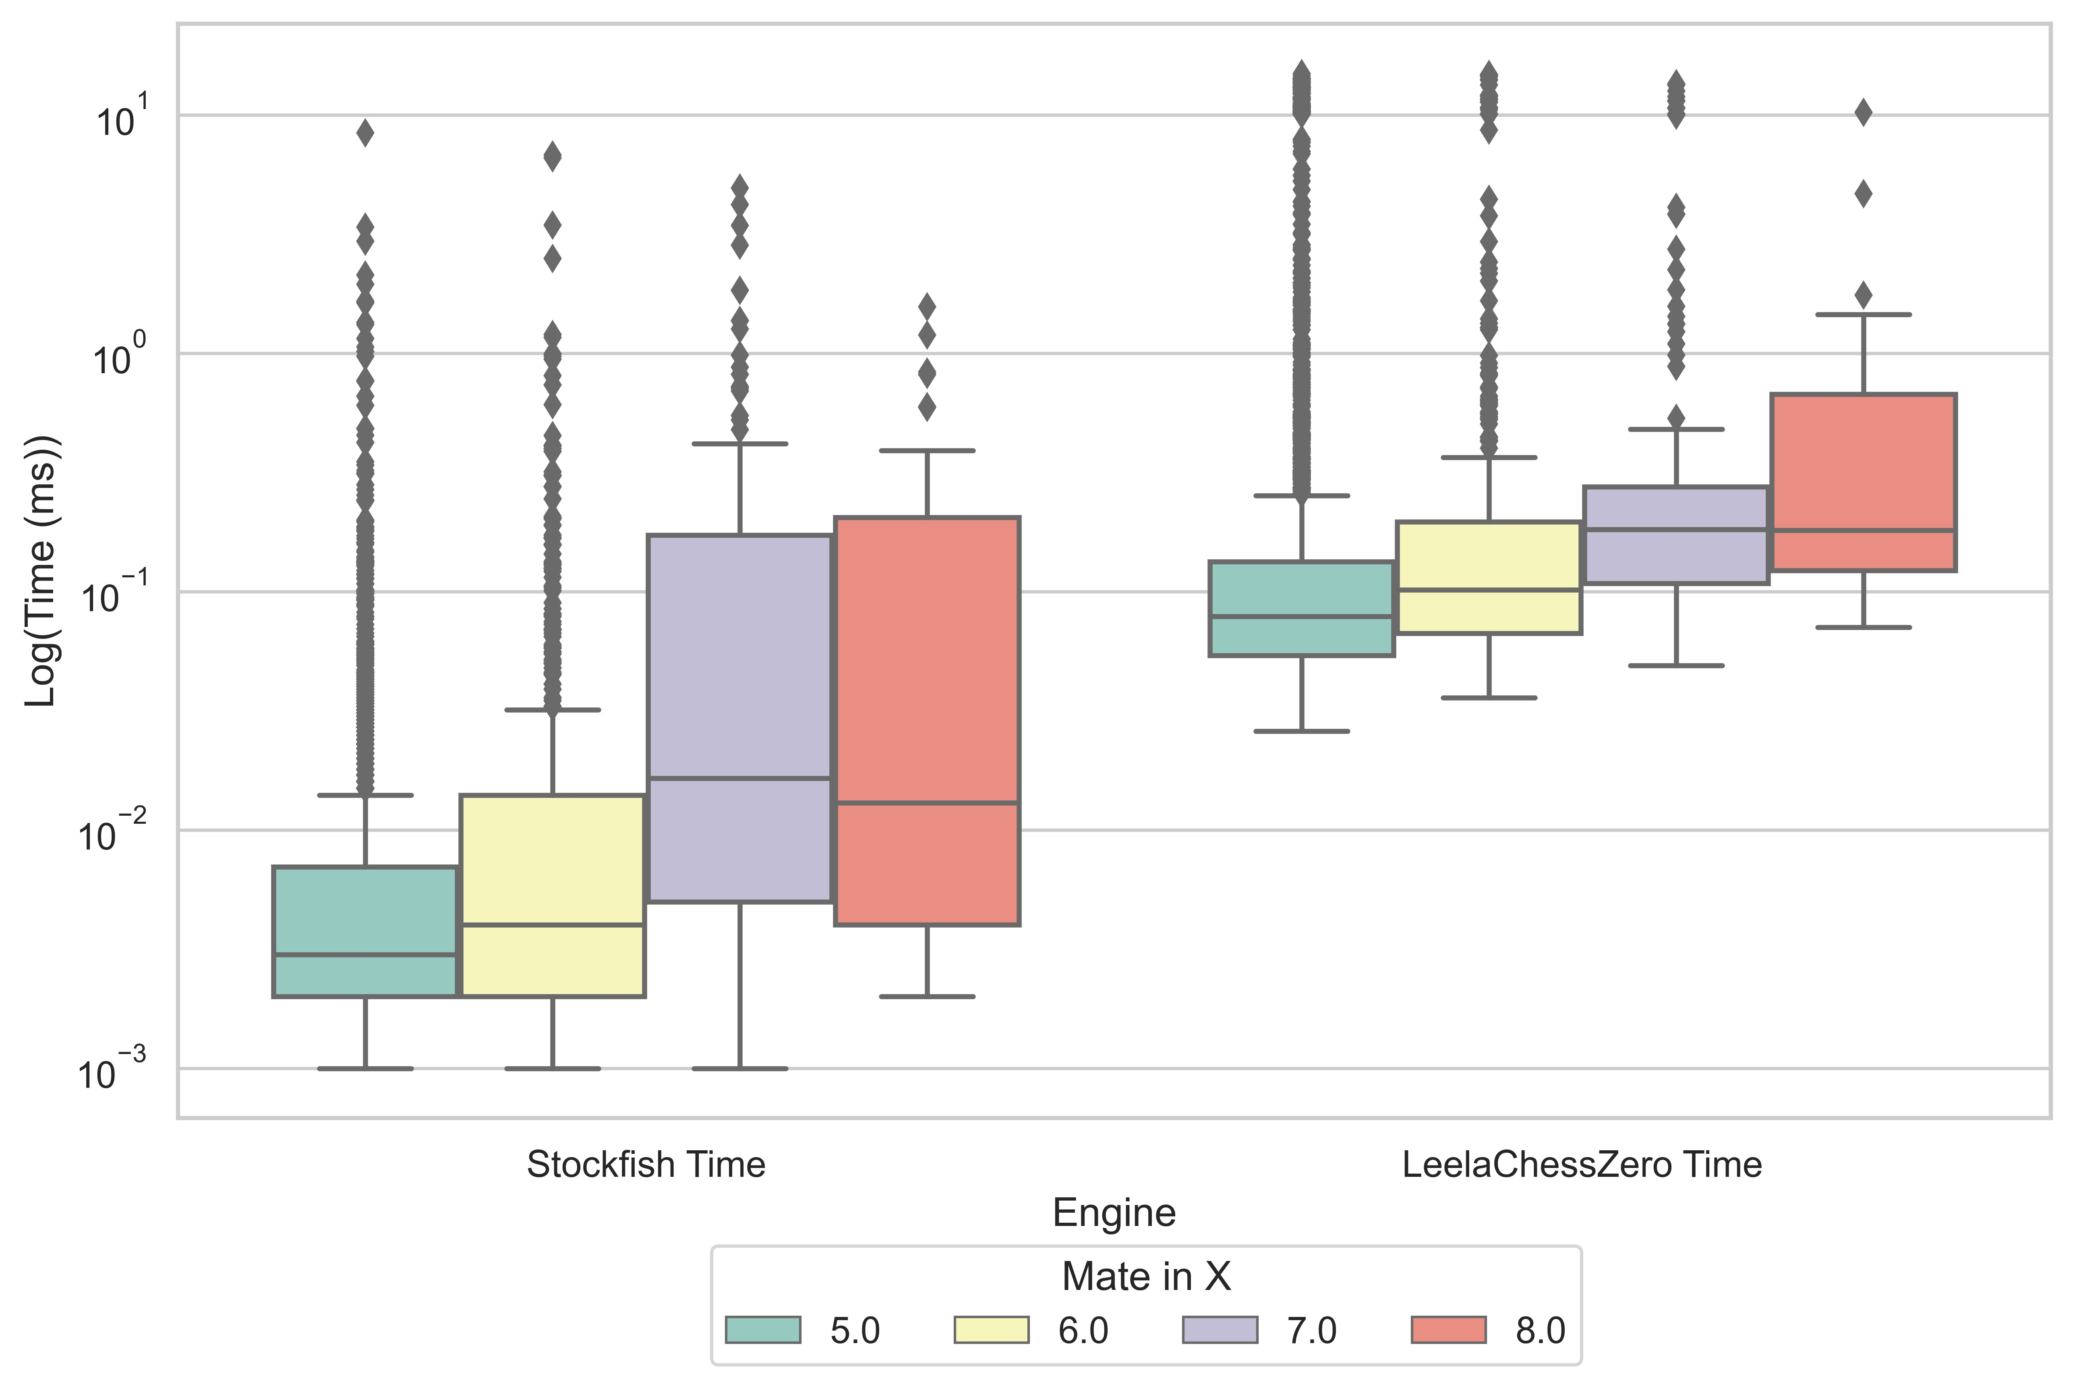

Figure - Seldepth Comparison of Stockfish and Leela Chess ZERO

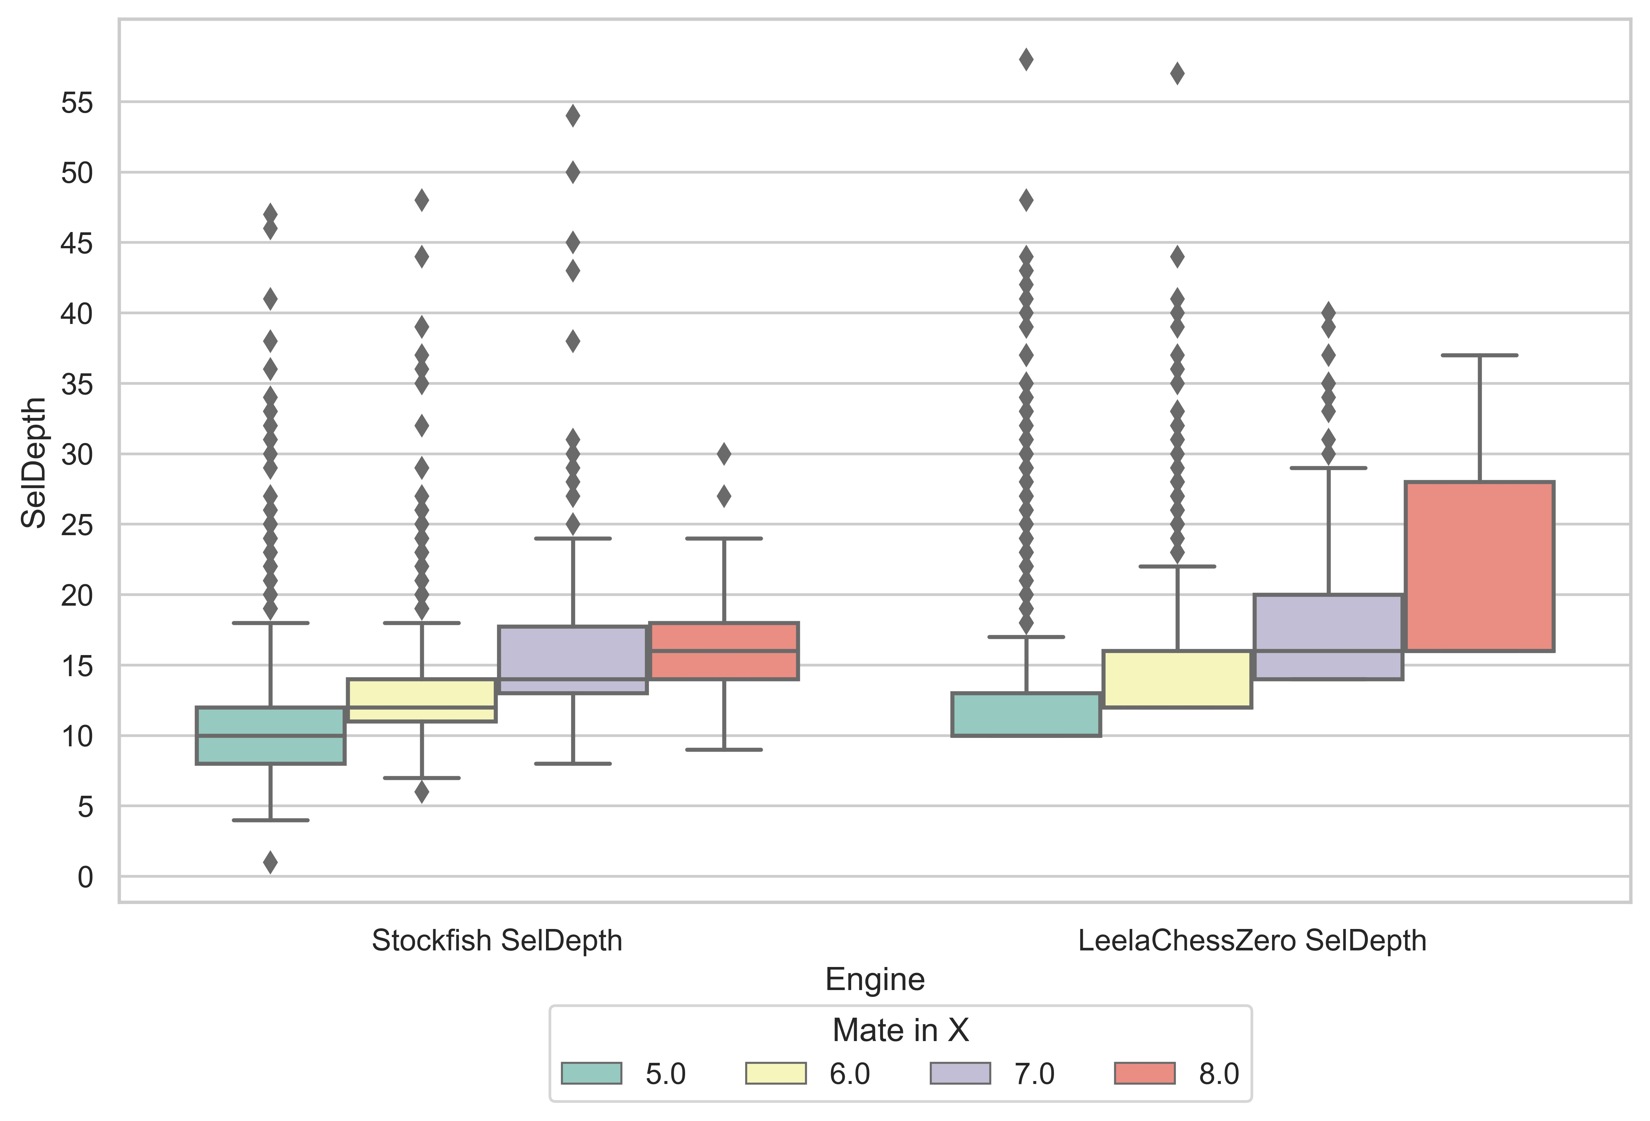

Figure - Nodes Comparison of Stockfish and Leela Chess ZERO

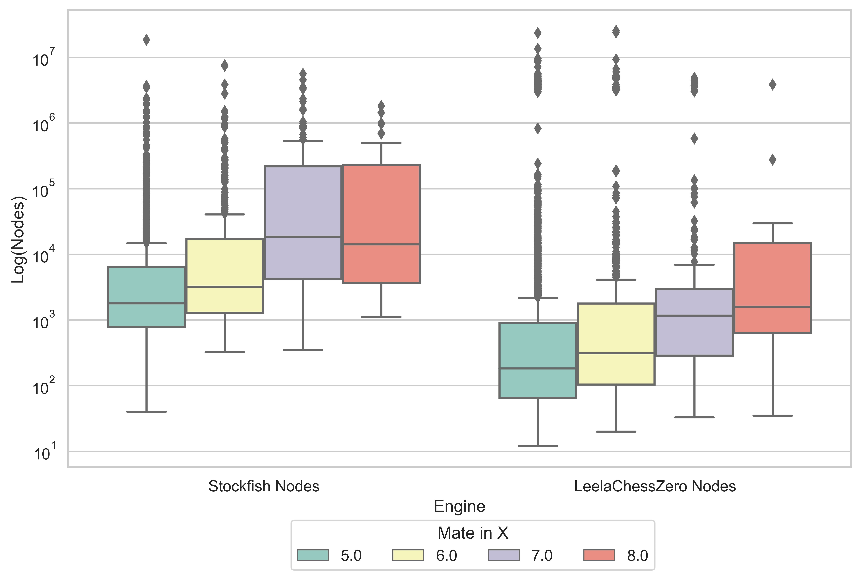

Along with the median difference for *time* and *seldepth*, the minimum values required for Stockfish to identify the mating pattern required with *time* being an order of magnitude lower and *seldepth* being half or less of Leela Chess Zero’s for three out of four mate pattern lengths,

## 6.2 Player Opening Distribution Analysis

### 6.2.1 Diversity Distribution

The initial analysis of the players by Gini Index and Shannon Index diversity metrics resulted in revealed an optimal cluster number *k* of 3.

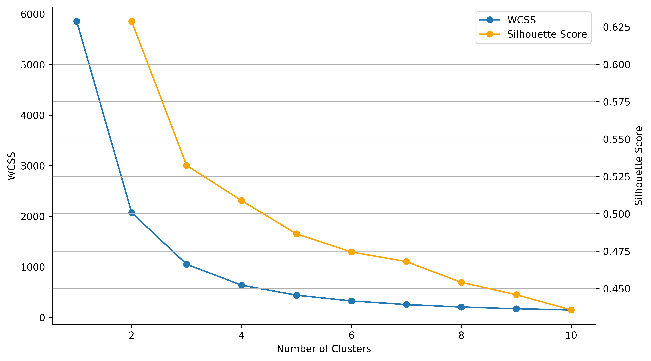

With this number the k-means clustering returned clusters that when used to display both the Gini and Shannon Indexes by density, show 3 distinct clusters.

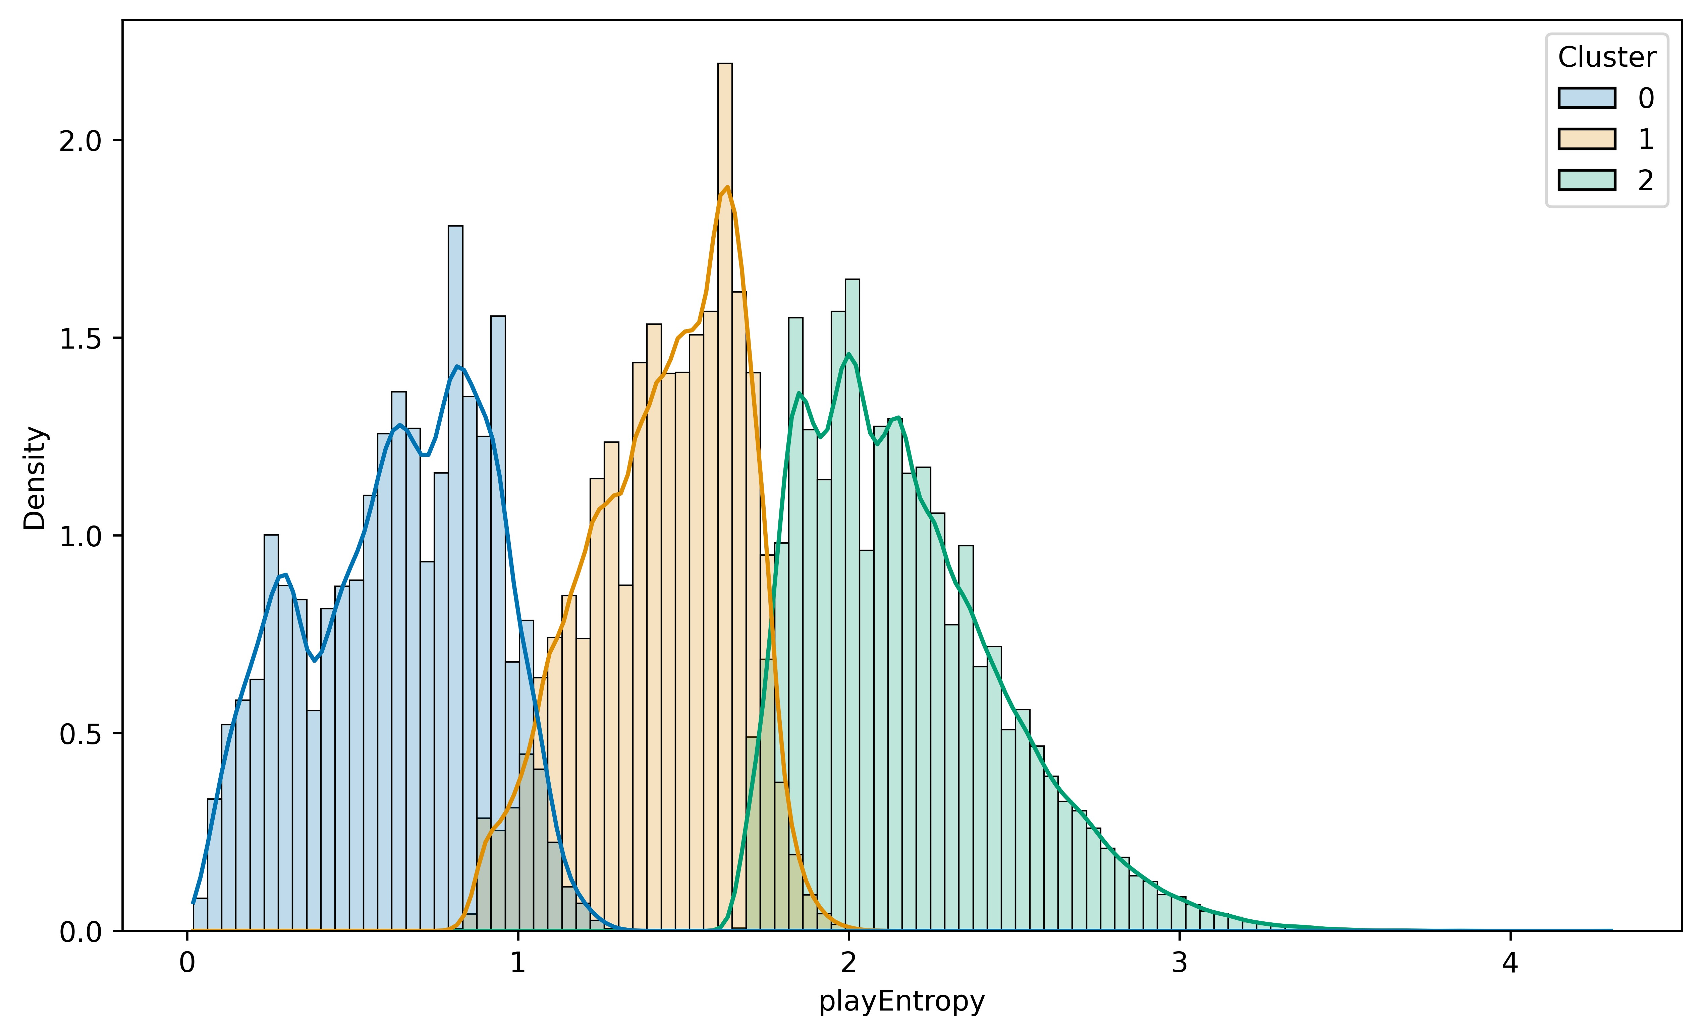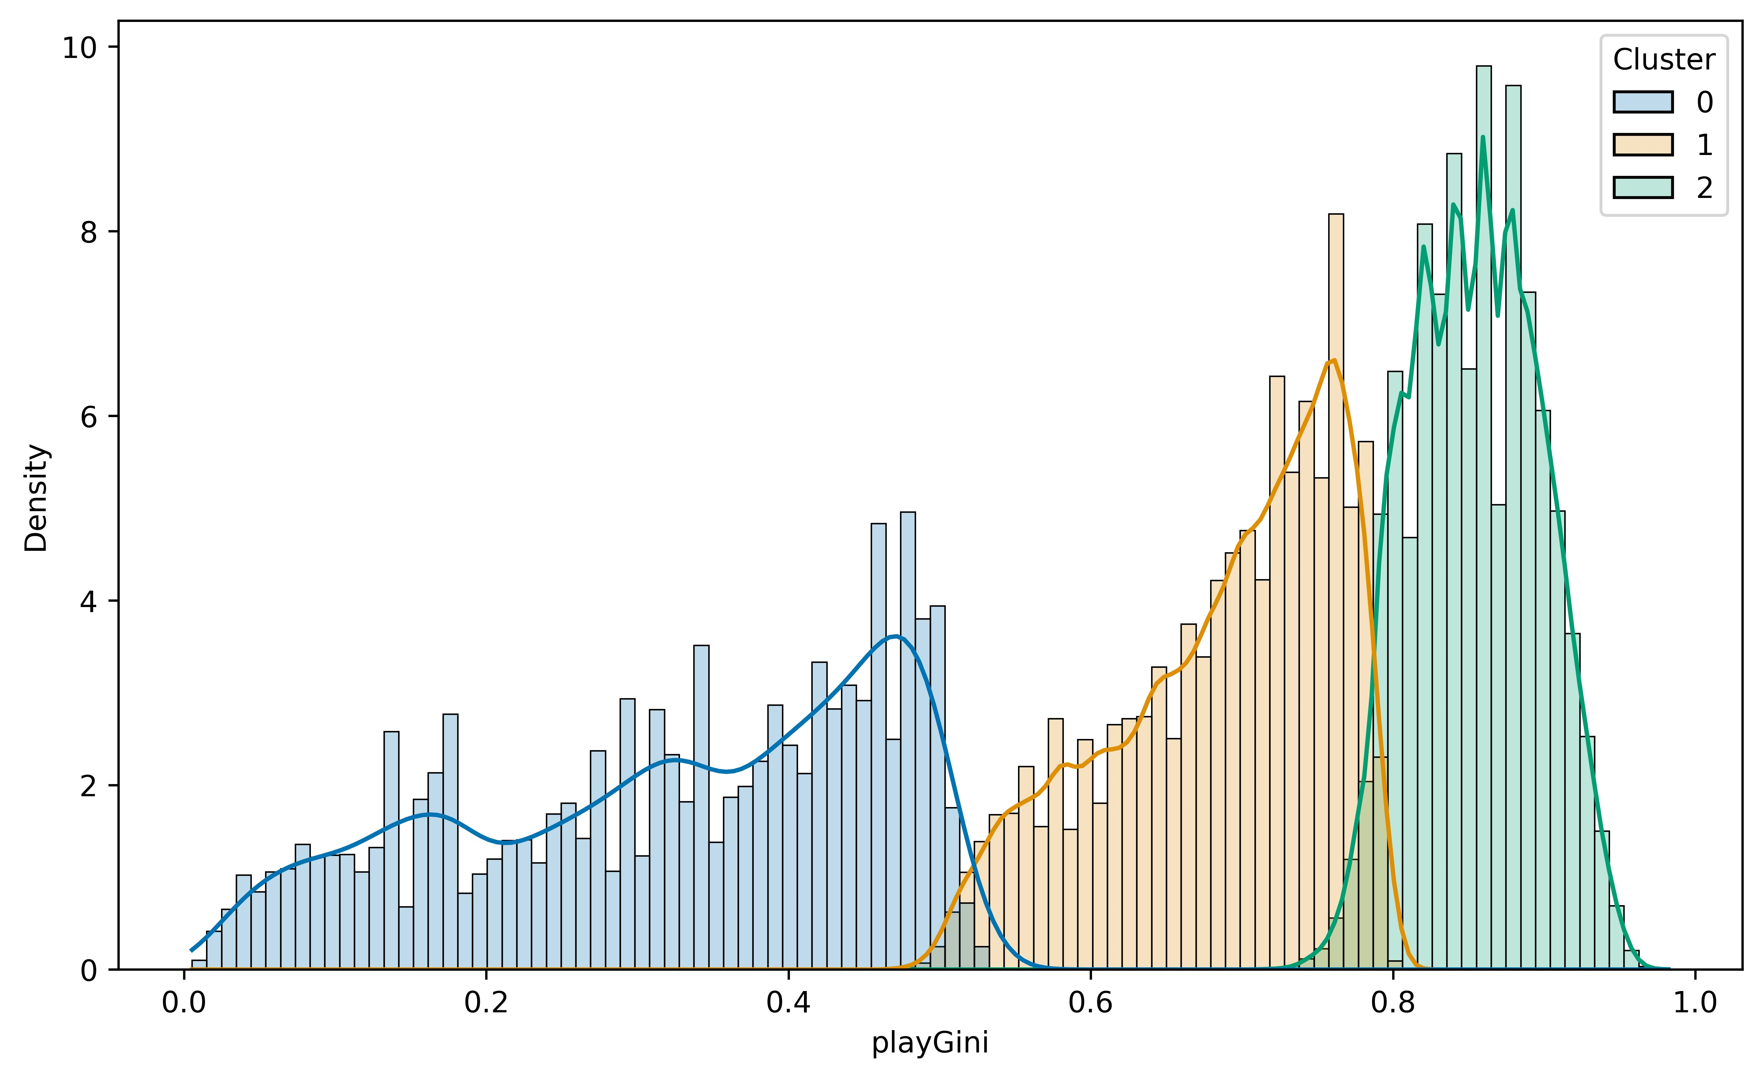

With these clusters, the count of players could be displayed with respect to each of the clusters. The histogram below with the resulting clusters as above show extreme overlap between the players based on rating. This indicated that based on diversity metrics, there are no distinct groups by rating. With this, it can be concluded that within this sample of players there is a range of diversity selection within the population with respect to player ratings. Below, a histogram shows the count number of players split by clusters based by diversity indexes. The stacked histogram shows a normal curve as expected with a measurement of rating at a population level. In this graph, the three distinct populations sit on top of one another. The implication of this, is that there are three groups of players that are selective of their openings in different ways, but these groups contain players from wide ranges of ratings.

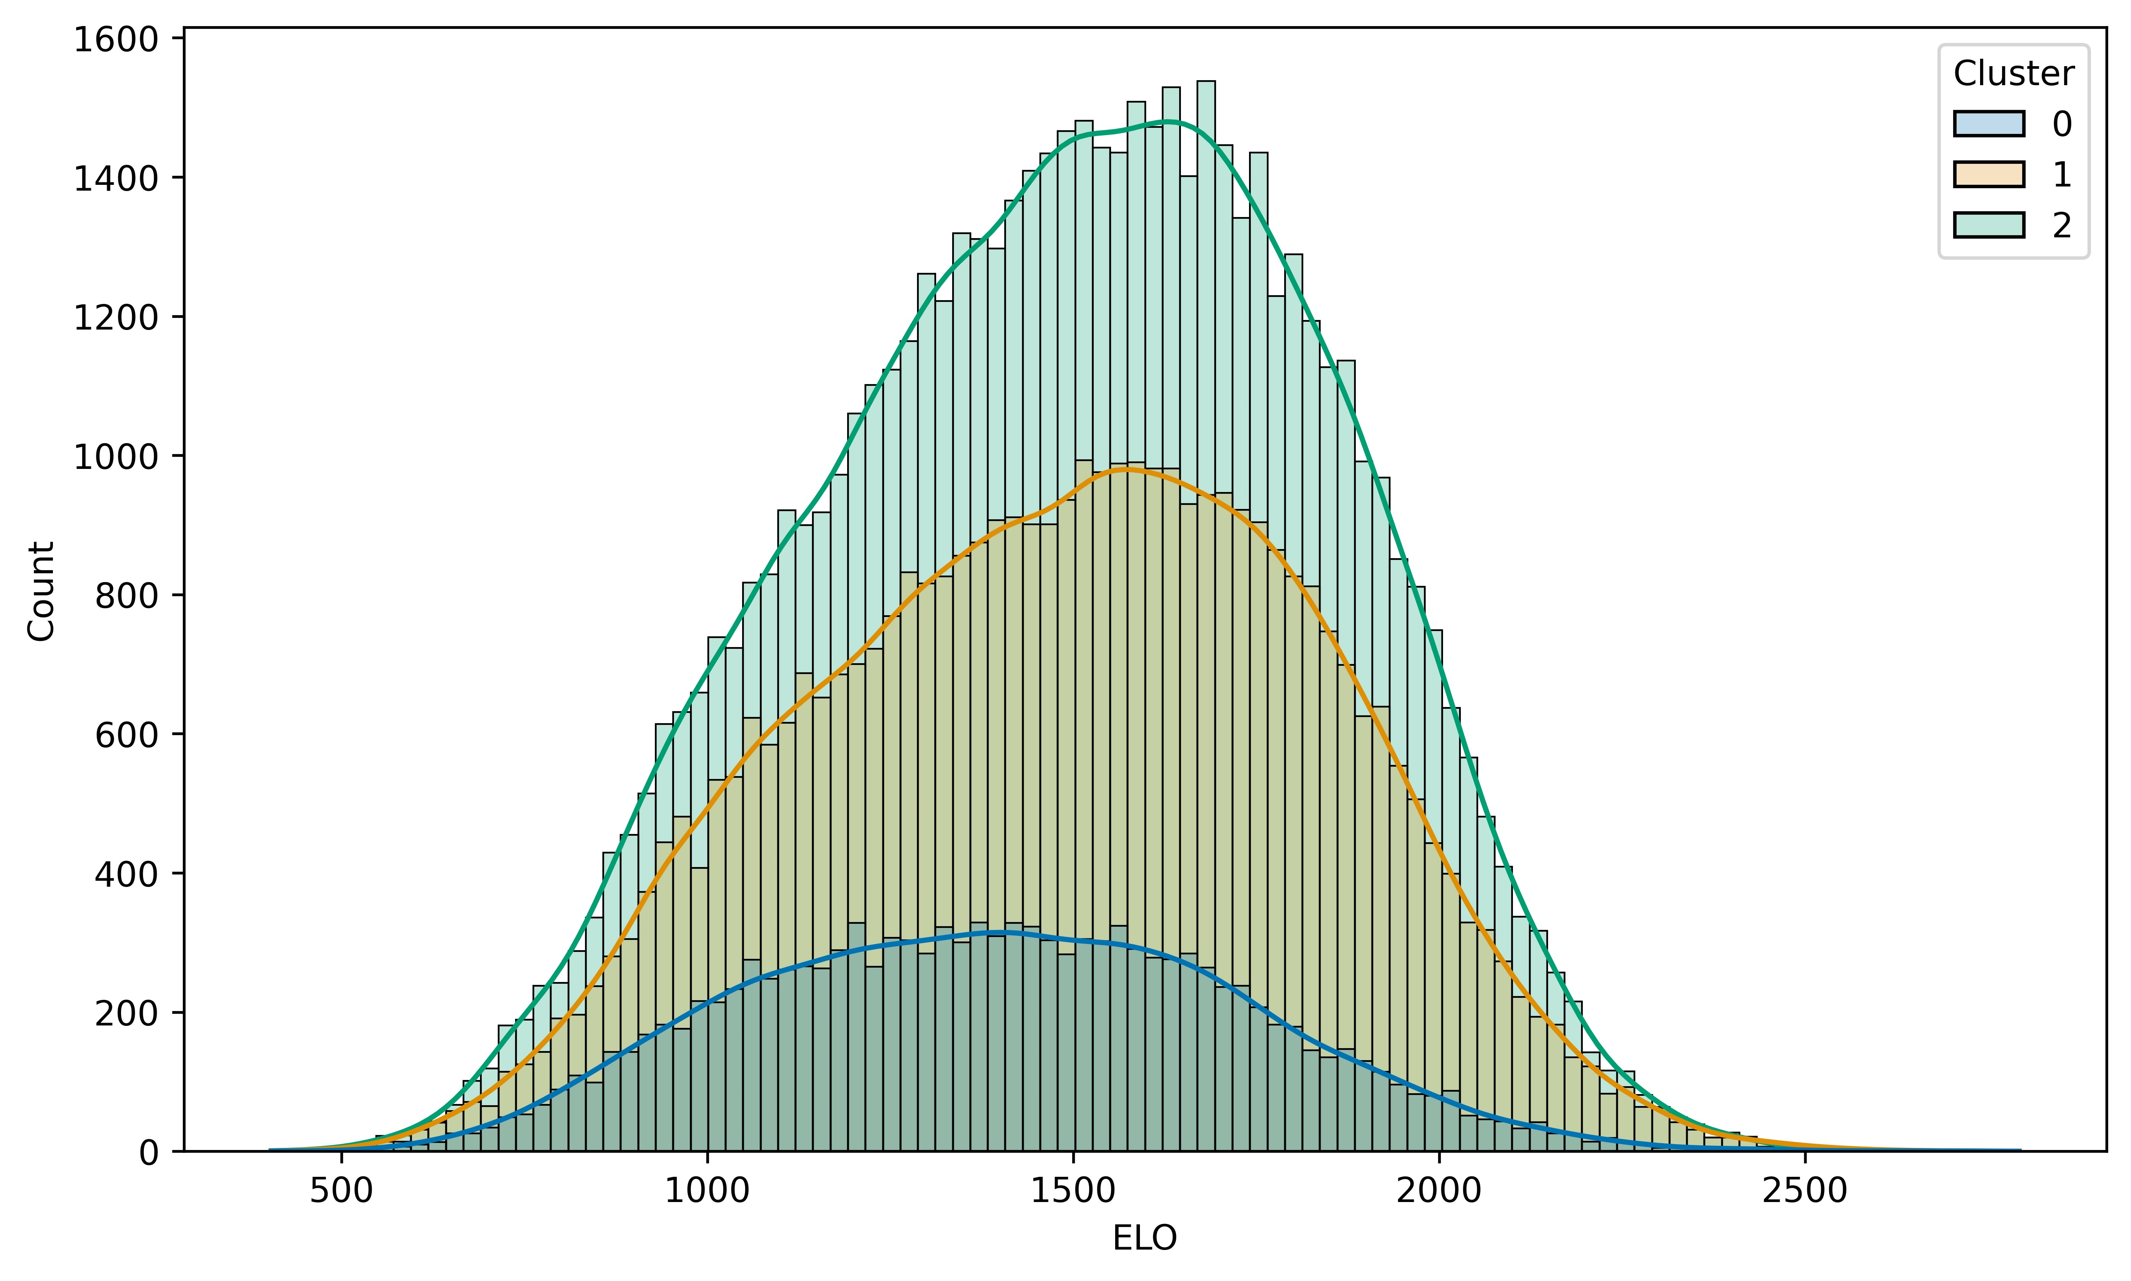

### 6.2.3 Distinction in Opening Repertoire

Following on from this, the nearest neighbour clustering analysis for determining player similarity in repertoire was performed. As before, an initial clustering to determine the optimal *k* value for the k-means clustering showed three distinct clusters. This can be seen below with a distinct elbow for the within-cluster sum of squares appearing for when k is equal to 3.

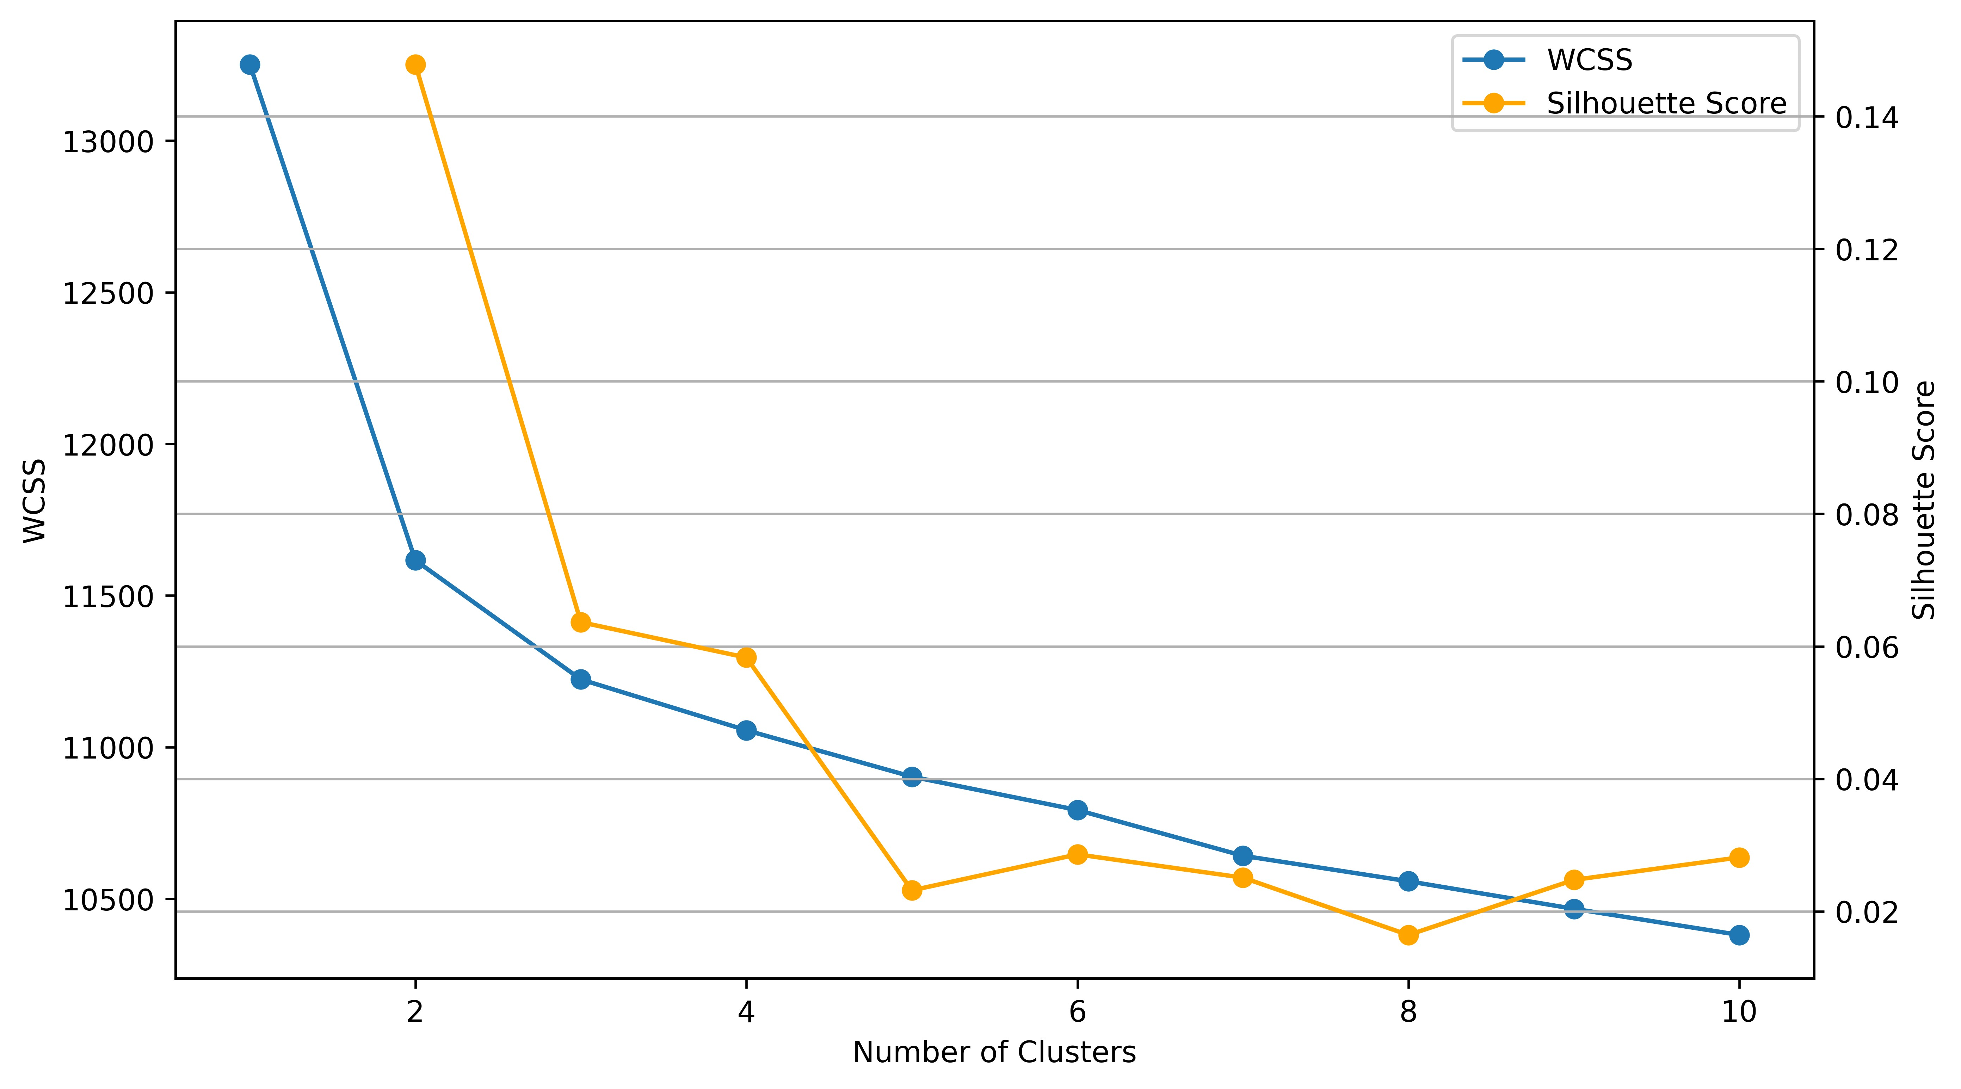

With this *k* value a clustering the count-encoded clusters were established and analysed where three distinct populations were found. Below a stacked histogram shows the result of the clustering plotted by player rating.

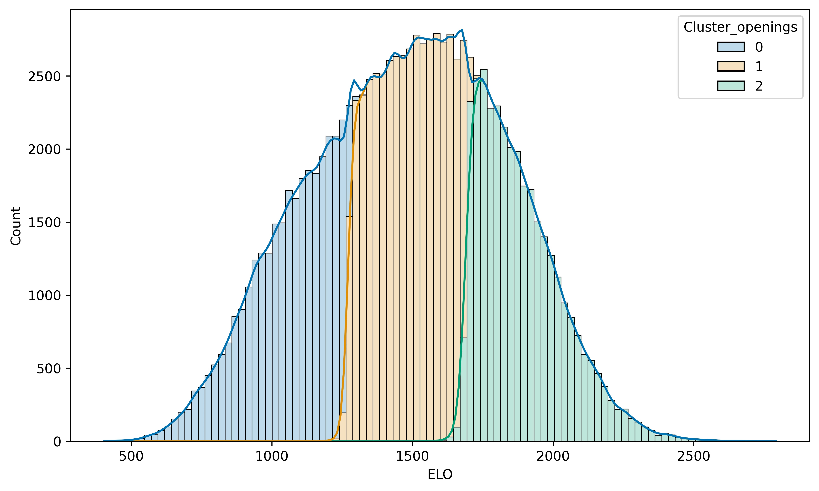

From this, it’s clear there are distinct rating points at which the players tend to select openings from different pools. There is some slight overlap which is anticipated as player rating based on Gecko ELO is a sliding scale, with players often moving up and down over the course of several games.

With this, the cluster values for players can be fed into the proposed recommender system. From there the differences in recommendations based on player similarity or success with specific openings can be compared to that of recommendations based on players that choose from similar openings with neighbouring ratings.

## 6.3 Engine Analysis of Openings.

With the positions analysed at the end of opening and every 5 successive white moves up until 15 moves, a comparison of these with Win/Loss ratio of the openings was performed. The first assessment considered is the correlation analysis, which showed some similarities in the 0th move position and 5th move position with the Win/Loss ratio.

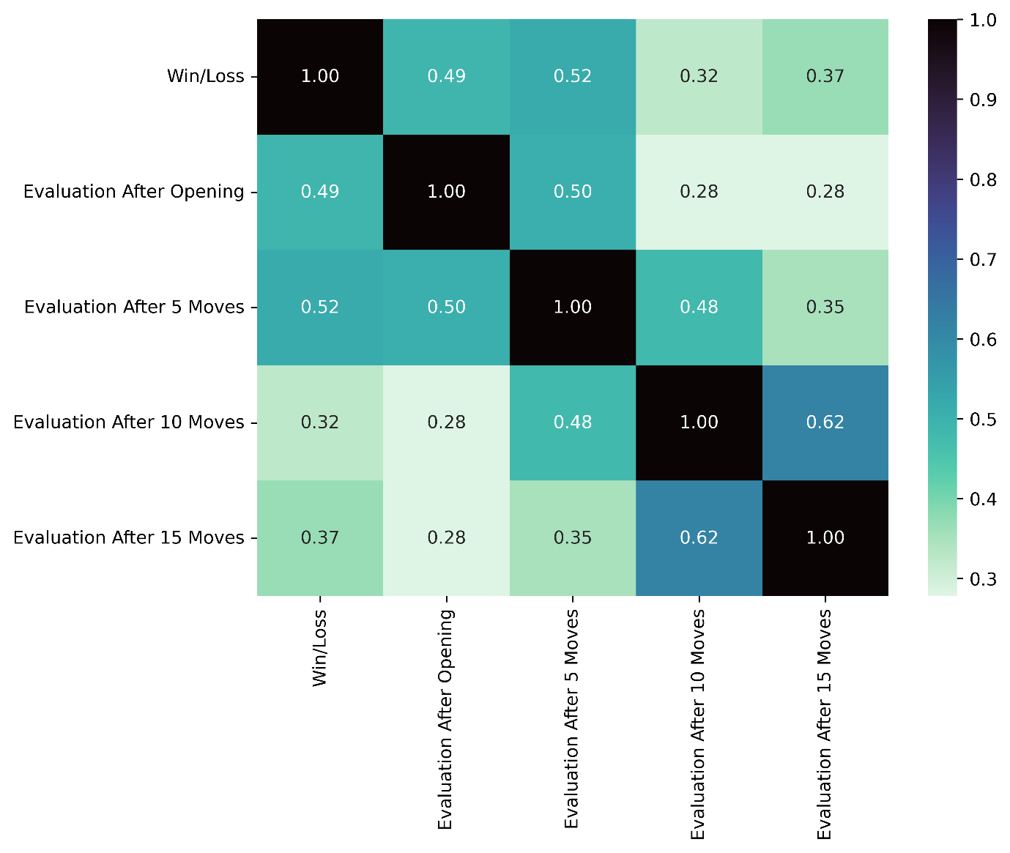

The Pearson Correlation value of 0.49 and 0.52 for the win/loss ratio to the evaluation at opening and five moves after respectively implies a minor relationship between the variables. Another key correlation here that is seen is the value of 0.62 between 10 moves post opening, and 15 moves post opening, indicating there may be a point post opening where engine evaluations stabilise.

Following on from this, to understand the relationship between the evaluations and win/loss ratio, the linear regression was performed with the results as follows.

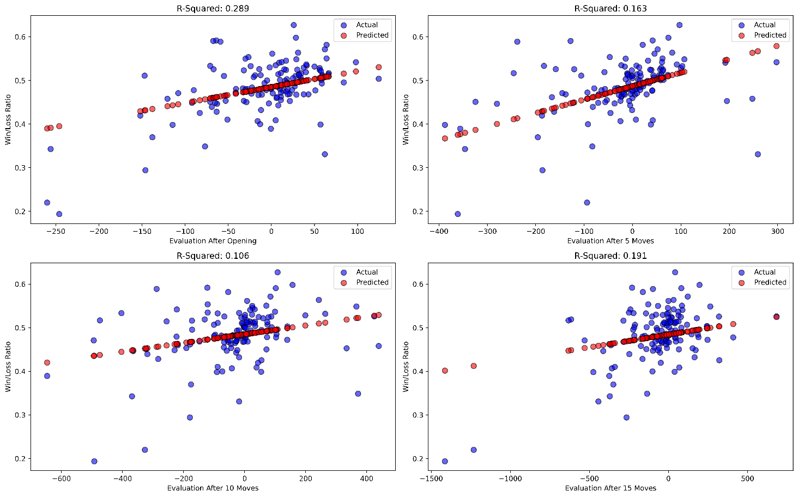

There appears to be a minor trend for the evaluations at each of the 4 points of analysis. Despite this, with R2 values ranging from 0.106 to 0.289, this trend is minimal.

## 6.4 Recommendation System

The nearest neighbour recommendation system was used to evaluate the 10 top recommendations for each player based on various metrics. Two heatmaps were generated based on the Jaccard similarity and the Sequence similarity. The heatmaps display each combination of recommendation metric along with the cluster/non-cluster based recommendations.

Figure - Jaccard Similarity of Recommendations

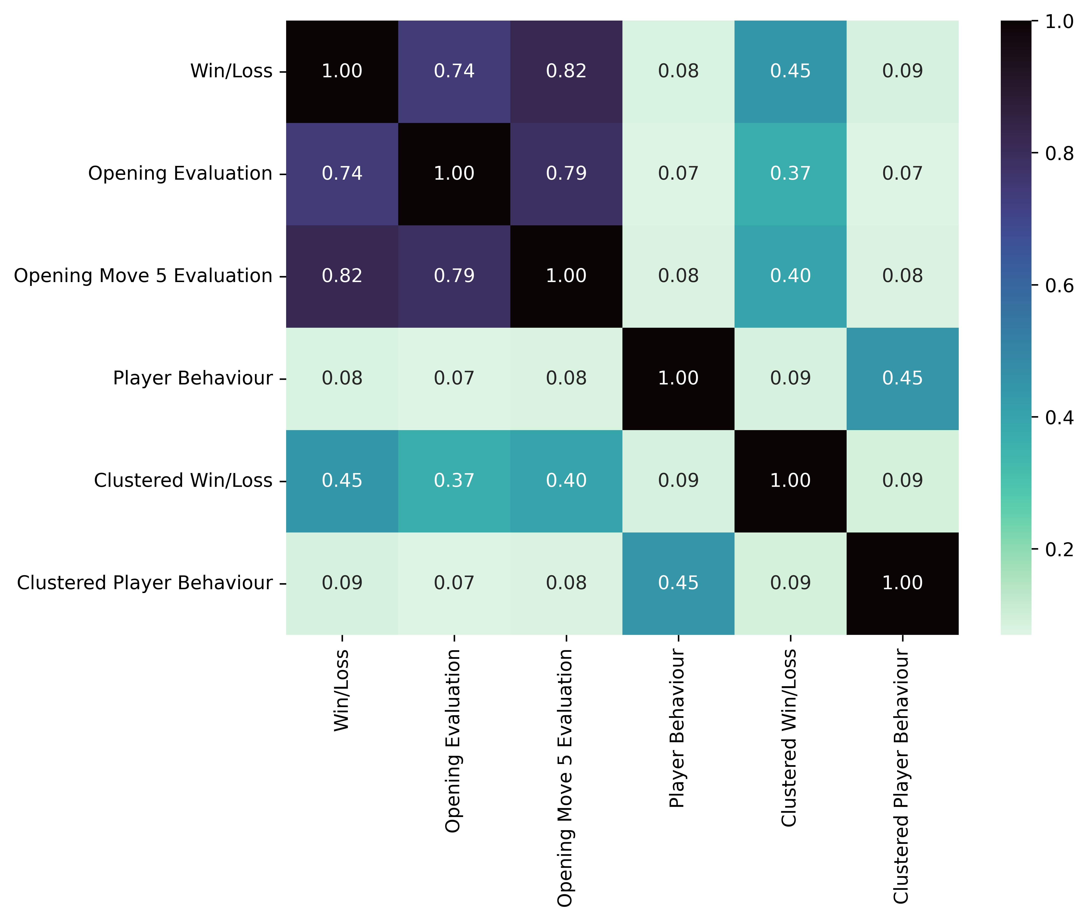

The Jaccard similarity shows the end of Opening evaluation and the 5 Move evaluation have high similarity with the Win/Loss ranking metric for evaluations of players. Notably the clustered recommendations for both the Win/Loss player success ranking and the player behaviour nearest neighbour recommendations both have an overlap similarity of 0.45. Player behaviour recommendations have an overall lower similarity with the ranking metrics with values of 0.07 with evaluation at opening and 0.08 with both Win/Loss ratio and 5 Move evaluation.

Figure - Sequence Similarity of Recommendations

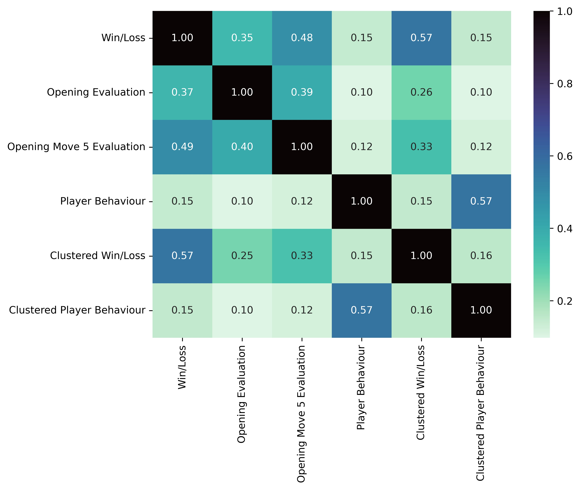

The Sequence similarity provides insight into the ordering of similar recommendations within the outputs for each player. As above for the Jaccard similarity, the clustered recommendations show equal similarity with their non-cluster counterparts. Overall, the similarity values are lower when compared to Jaccard. This is not unexpected and shows that although there may be overlap between the recommendations, the point at which they are recommended in the lists by valuation is not as consistent. As above with Jaccard similarity, player behaviour similarities are low with values of 0.10 and 0.12 with evaluation at opening and 5 Move evaluation, and 0.08 with Win/Loss ratio.

# Chapter 7: Discussion

The research and analysis in this paper has demonstrated the role chess engines can have as data analytics tools on the game of chess, rather than on the individual game analysis level. By using engines on an aggregated dataset level,

The complexities of understanding players with respect to how they interact with openings has been investigated and demonstrated with linkage between a player’s rating and the opening they may be more inclined to choose.

Combining this information has given rise to a collection of recommendations, wherein the player specific recommendations can be compared based on the metric used for each system in the collection. In this discussion section, the results of the research that was completed will be discussed and broken down by their implications with respect to the objectives set out in in the initial stages of this project.

## 7.1 Puzzle Analysis

The results obtained from using the chess engines Stockfish and Leela Chess Zero, two of the top open-source engines competing in the Top Chess Engine Championships, has shown indications of power gain of selecting the correct tool for a *Mate in X* analysis. The aim of this test was to determine the chess engine which could provide more depth of search and overcome a potential limiting horizon to provide an evaluation that will be reflective of the current position.

By measure of *time*, *seldepth*, and *nodes* Stockfish outperforms Leela Chess Zero with statistical significance. The boxplots showed the significant difference between them, allowing for a decision to choose Stockfish as the engine to gain an alternative insight into the value of openings.

This result was not unexpected, with Stockfish having manually crafted heuristics to specifically handle mating problems. Leela Chess Zero, being designed by a hands off neural network approach, may not have encountered specific mating patterns in its training with the game of chess having such a vast array of endgame combination possibilities. Despite this, Stockfish’s performance lead on all the metrics considered showed its search performance has the ability to overcome the horizon effect. This is particularly evident in the *seldepth* value, where the boxplot shows many instances in which the engine found a solution at a depth that was lower than the expected depth required.

## 7.2 Player Opening Distributions

The objective of establishing the relationships between players and choice in openings was to provide a basis of understanding for dynamics of a recommendation system based on players with similar opening choice styles.

The outcome of the diversity index clustering to divide players by rating gave clear indication that there are select groups of players that have different opening choice tendencies. These players when split out by their rating showed little difference in rating, with the histogram showing diversity in opening choice being distributed throughout all ratings. With this in mind, the alternative grouping of players based on their selection of openings rather than how they select their openings was considered and investigated.

This alternative grouping, which utilised a k-means nearest neighbour clustering method, determined the similar players by grouping based on the players and the openings they used within this sample of games. The count-encoded data fed into the machine learning algorithm produced three distinct clusters, the same value seen above in the diversity index assessment. Unlike the previous analysis though, when displayed by rating, three distinct clusters with only minor overlap were determined to exist.

This was a key piece of information with respect to building a recommendation system and had to be considered. The main driver for this consideration as part of the recommendation system development was to minimise the recommendations for players that may be considered outside of the realms of choice if they independently chose new openings for their repertoire.

## 7.3 Opening Engine Analysis

With Stockfish being chosen as the preferred engine for this analysis, the objective of determining evaluations for opening positions and the five move intervals following was addressed. This objective is where we can see the use case of engine analysis as an alternative method to evaluate openings rather than taking the win loss ratio as a statement of fact for the potential success.

The correlation analysis of position evaluation reveals a minor correlation between the position evaluation at the end of an opening play and 5 moves after. A further investigation into the relationship between these variables shows a minor positive trend indicating with r2 values of 0.289 and 0.163. These values may indicate more decisive value to the win/loss ratio in terms of representing the openings on a player aggregate scale but are exclusive of the idea of opening theory. The benefit here of understanding the aggregated engine evaluation, is that engines can determine lines of play which are likely to provide minor benefits to player position.

When it comes to considering an opening based on the engine evaluation, these minor increases in position or piece advantage can have a large impact on a game while only having a minor impact on the evaluation score. Meaning that openings chosen based on engine evaluation may be subject to more theory, which studious players could take advantage of when facing opponents that are less inclined to investigate theoretical outcomes of a positions.

## 7.4 Recommendation System

The final proposed objective in this project is a culmination of the previous objective outcomes. The recommendation system that was produced and evaluated considered the best engine for engine evaluation of openings; the evaluation of openings from the preferred engine; and the clusters that may provide players with openings that are more in line with their current repertoire.

The approach of extracting similarity measurements based on a numeric overlap and ranked ordering gave way to an interpretation that is multi-dimensional. The Jaccard Similarity rating between the Win/Loss ratio and the Opening and 5 Move evaluations indicates a high overlap with values of 0.74 and 0.82 respectively. This result combined with the Sequence similarity metrics of 0.37 and 0.49 respectively shows that multiple openings, between 7 and 8 out of 10, are recommended based on a players historical success with openings. By using these metrics, a potentially stronger recommendation for a player based on multiple values could be given with the implementation of a hybrid model. The benefits of using a chess engine, a tool typically used on an individual level, as a data analytics device can been seen here. With recommendations based on a players success being backed by the current most powerful chess information producer (Wiki, 2023), a player can be more certain of their decision to test a new opening.

Another section of the recommender system developed indicates an interesting approach for recommenders in the form of the clustered based outputs. These outputs reveal an overlap of between 3 and 5 openings with both the Win/Loss recommendations and the opening evaluation recommendations. Players looking to expand their repertoire may not be inclined to diverge from the comfort of knowledge. To bear this in mind, this overlap means a multi-metric-cluster based recommender system, combining all the recommendations of openings with the best chances of winning without deviating from the sets openings played by players within a cluster.

Finally, the player behaviour shows an average overlap of less than 1 with each of the systems developed before. This provides a unique alternative angle for a players approach in choosing an opening as it may not be the best opening based on other players that had success with similar repertoires. This method gives players a chance to explore their play style and how they like to attack, defend, or implement tactics.

This section has shown not only how extracting the apparent minimal data of players, openings, ratings, and their moves can lead to the development of a system that can benefit the player; but also how using a complex analytical engine can boost such a system and provide confidence with respect to the outputted recommendations.

# Chapter 8: Conclusion

In this paper, the process of determining the chess engine with the best potential for handling the horizon effect was determined by comparing the engine parameters at which a *Mate in X* was solved. The analysis showed Stockfish to outperform Leela Chess Zero for this use-case which informed the decision of using it as the chess analytics tool for the evaluation of openings positions.

A collection of white specific openings was extracted from a collection of games from June 2023. These games were part of a large database sourced from Lichess.org in the form of a PGN file, where they were processed using a function implementing a line reader with specific tasks to determine if a game was eligible. The games, filtered by time control of 10 minutes or more, were pre-processed to extract openings which were appeared with a frequency and diversity of player use to render them eligible for a recommender system.

The eligible openings were processed using a function that sampled the games, stratifying by opening to ensure there was sufficient occurrence to allow for a balanced analysis, and evaluated using Stockfish on the end of opening positions, and the position and 5, 10, and 15 moves post the opening. These evaluations were then aggregated and compared with the historic win/loss ratio for each opening to determine the relationship between how a game is evaluated by an engine and the result of the games.

An exploratory process investigated players and their behaviour with respect to how they choose openings, and which openings they are inclined to choose from. More specifically, the relationship between the players chess rating on Lichess.org, and their opening selection behaviour revealed measures diversity in selection of openings were distributed throughout all rating levels using k-means clustering. Following from this, a k-means clustering was performed using transformed count-encoded player-opening data to determine where on the rating scale players tend to choose from different pools of openings.

The combined results of the previous processes were culminated into the ultimate objective, where recommender systems were developed based on combinations of the other objective’s outputs. The comparison of these recommender systems showed overlap between metrics for ranking openings from players with similar success in shared openings used. It also revealed that a recommender system built on a player’s behaviours, commonly denoted as “play style” by chess media, showed little overlap with the similar success based systems. The clusters established by the player-opening distribution objective showed slight overlap, but the lesser similarity indicated that the use of clusters may provide avenues for players to get opening recommendations that may not diverge too much from their current opening selection pool.

Although the objectives set out for this research have been fulfilled, limitations occurred during the analysis that must be addressed.

The consideration is that of granularity. Even with 10 million games extracted from the chess game database, some of the more complex, theory-specific openings only occurred with low frequency. These openings are identified with the *Variation* section of the name, with some having 2+ variations in their assigned name. Without a sufficient sample of these openings, they could not be included within a recommender system as the aggregation values of both win/loss ratio and chess engine evaluation may not have been reflective of the real-world values. This element could be addressed with a more informed sampling method, with the database being processed, rather than collecting all eligible games, a stratified approach could be taken.

The second point to consider when reviewing the results of this research is the application of the analytics engines to the chess openings. In order for an engine to analyse a position thoroughly, it may need to be run for excess amounts of time. With time constraints being a factor for this analysis, a limit of 1 second was required for each game analysis. While this sounds like a small amount of time, engines often perform accurately, but it introduces an element of the horizon effect. The evaluation of the optimal engine for this research was intended to mitigate this, but by allowing an indefinite analysis until stabilization, given sufficient time, the most reflective engine analysis possible could be achieved.

Future scope for the results of this project is that of the beneficial incorporation of chess engines, and the combining of recommender systems to implement a real world use case for large scale data analytics within the chess environment outside of standard game analysis. It has been demonstrated that chess is a complex task to analyse, and the specialised engines can process massive volumes of data with such ease that when considering future chess related research there is a place for their function.

The development of a recommendation system based on historical data and chess engine evaluation, provides a platform at which world of chess specific machine learning, and broader data analytics machine learning can be integrated together to produce tools that provide benefits to chess players as a whole.

# Appendix A: Workflow

# Appendix C: Data Permissions

# Reference List